Jeffrey Lansford

9/17/2020

Chapter 3

4.



<assign> -> <id> = <expr>

<id> -> A | B | C

<expr> -> <expr> + <term> | <term>

<term> -> <term> \* <factor> | <factor>

<factor> -> ( <expr> ) | <id> | <id>++ | <id>--

11.

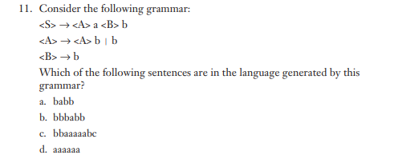

a & b

<S> -> <A>a<B>b

* babb

<S> -> <A>a<B>b

* <A>babb
* <A>bbabb
* bbbabb

21.

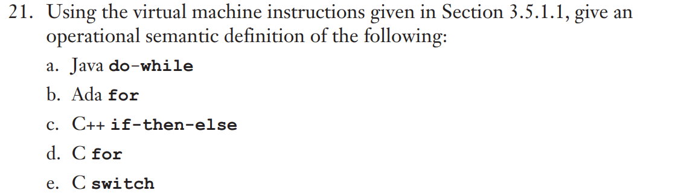

Java Do-while

do { statements} while (expr);

Operational Semantic:

L1:

…

Statements

…

If ( expr == True ) goto L1

…

Ada for loop

For var in A .. B loop

Statements

out loop

Operational Semantic:

var = A

L2:

If (var <= B) goto L1

goto out

L1:

…

Statements

…

Var = var +1

Goto L2

out:

…

C++ if then else

If ( expr) {

Statements

}

Else {

Statements

}

Operational Semantic:

If (expr == True) goto L1

Goto L2

L1:

…

Statements

…

Goto out

L2:

…

Statements

…

out:

…

C For

For (expr1;expr2;expr3){

statements

}

Operational Semantic:

expr1

L2:

If (expr2 == True) goto L1

goto out

L1:

…

statements

…

expr3

goto L2

out:

…

C switch

Switch (A) {

case c1 : S1

case c2: S2

…

Case cn: SN

<default>

}

Operational Semantic:

If (A == c1) goto C1

If (A == c2) goto C2

…

If (A == cn) goto CN

goto out

C1: S1

C2: S2

…

CN: SN

out:

…